Julia Sveen
Case Study – Clustering for Similarities in the NFL Draft

1. Choose either the RB_Clustering or WR_Clustering dataset and import it to R Studio.
Examine the data. Remember to then create a new dataset by only selecting the
quantitative variables (columns) we want to cluster them by. Then, standardize (scale) the
data. What does it mean to standardize a variable?
Standardization is the process of converting a variable in accordance with a common scale. In this case, we are converting the variables to their z-score value (how many standard deviations away from a mean).

2. Our goal here is to create clusters of players that are similar to one another but dissimilar to
the players in the other clusters. In this way, we can classify or label them appropriately, and
identify which types of NFL players our 2024 Draft prospects are most like. Start by creating
an elbow plot to identify an optimal number of clusters. Remember that this process can be
somewhat subjective. How many clusters are recommended for your data?
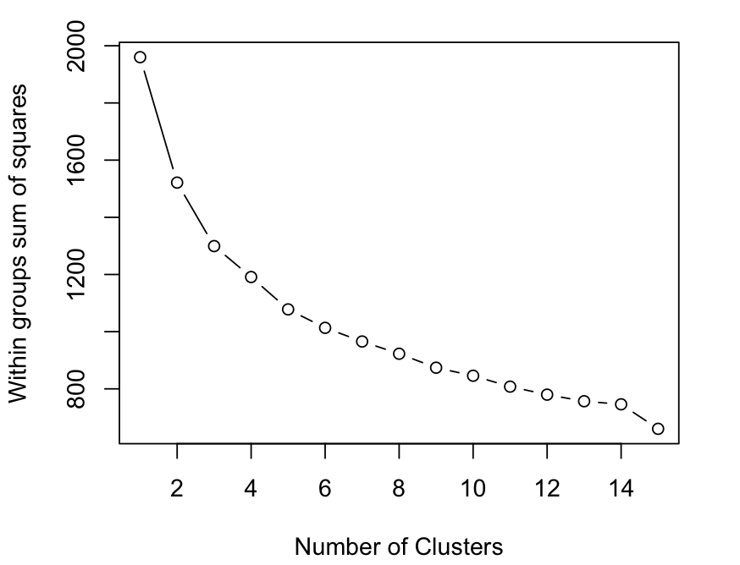
5 clusters are recommended for my data.

3. After determining the recommended number of clusters, conduct a cluster analysis to group
the players. Create a cluster plot visualizing the clusters across the top two dimensions and
paste it below.
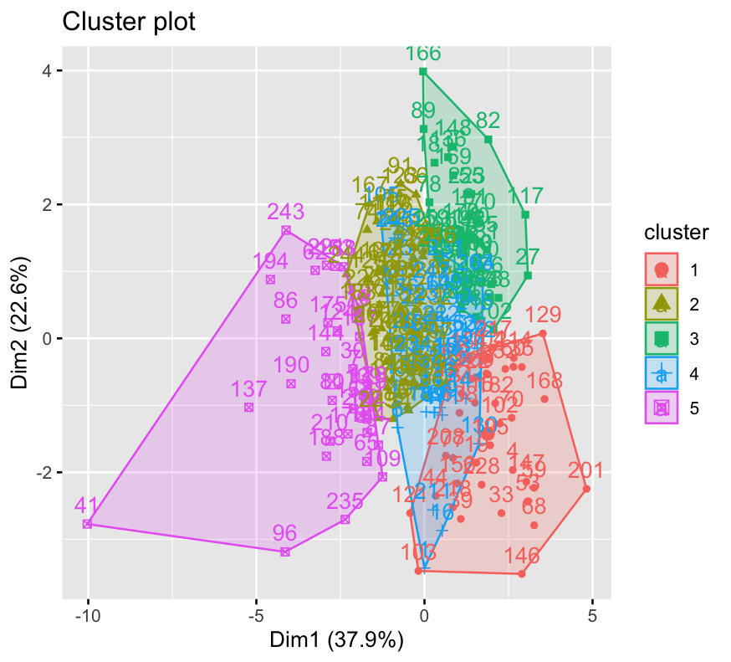

4. Using either a table or bar graph, show and discuss (below) the averages for your selected
variables across each cluster. What types of running backs or wide receivers seem to
appear in each cluster?
In cluster 1, there seems to be a lot of tall, agile wide receivers who appear to be strong players, but their natural abilities don’t indicate that they are necessarily good in the metrics that matter the most in games such as receptions and receiving yards. In cluster 2, the players do fairly well on average in metrics such as receptions and receptions per game, but they may not be able to be successful in those contested ball situations due to their lack of agility. Cluster 3 and 4 are similar in the sense that those players seem to underperform (or are projected to underperform) in games, with cluster 3 being far below the mean in receptions, receiving yards, and receptions per game. Cluster 5 seems to include underrated players, those who are not very tall or agile, but perform well in terms of receptions, receiving yards and receptions per game.

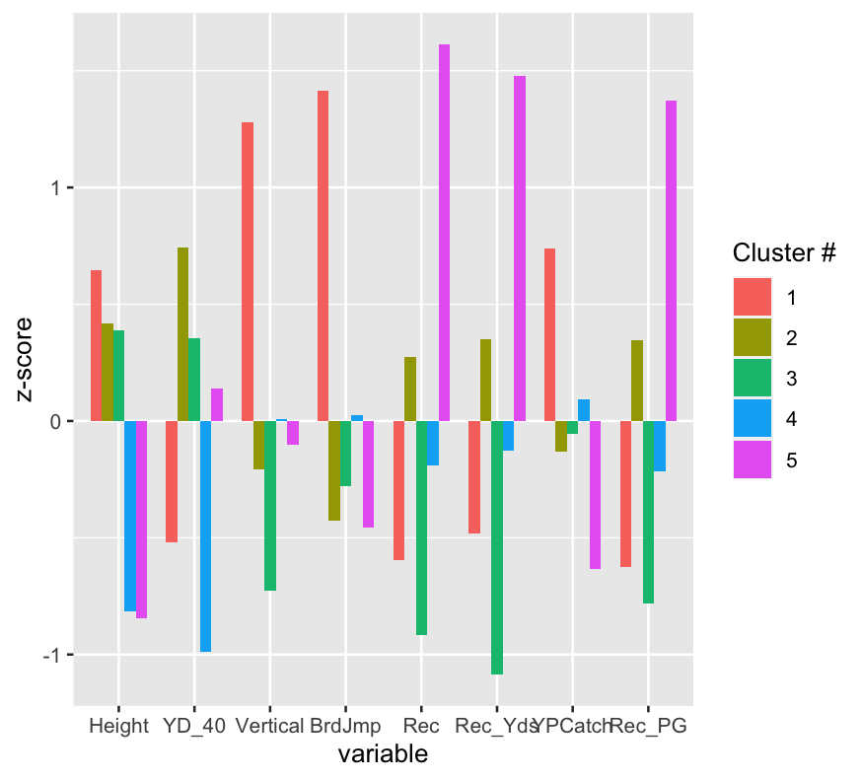

5. In which clusters do the 2024 prospects appear? Who are some NFL players that are similar
to them?
The 2024 prospects appear in clusters 1 and 4. Xavier Worthy and Ladd McConkey are in 4, while Johnny Wilson and Adonai Mitchell are in 1. Looking at both of those clusters, some similar NFL players are Jaxon Smith-Njigba (cluster 4), Zay Flowers (cluster 4), Seth Williams (cluster 1) and Kadarius Toney (cluster 1).

6. Bring in the Overall or Round variables on the backend to see if certain groups of players
(clusters) appear to get drafted earlier or later (don’t forget to remove NAs with na.rm=TRUE
if necessary). Do you notice any differences or trends?
For the most part, the groups aren’t far off from each other in terms of draft pick. Group 4 tends to get drafted the earliest, averaging the 3rd round or about 95th pick. Then it is group 1, group 5, group 2, and lastly group 3. I will say this data is a little bit odd, I would assume that group 1 or 5 would be drafted higher on average, but again, the data is fairly close.

